**Overview**

Work individually to understand and establish the specifications for a PC dedicated to a specific task or application.

My PC application topic Is: Media production and streaming computer

Answering the student questions will help you to develop a deeper understanding of the main components of a personal computer. It will also help you to identify the features that are most important for your specific PC application topic and the features that are nice to have but are not as critical for your topic.

Preparing a brochure explaining your PC application topic and your selection of personal computer components and features will help you to summarize what you have learned from the student questions. The brochure will also help you to share your findings in a “tradeshow” to be held in class.

The date for the “tradeshow” is: __________________________

**Student Questions**

1. Think about your PC application topic. Do some research to find general answers to the following questions.
   1. How important is computer speed for my topic ( High / Medium / Low)? Justify your answer using examples of how a computer is used to perform a task related to your application.
      * For my topic, computer speed is very important. The speed needs to be high because in media production we want the speed to be fast in order to get the work done faster.
   2. How important is data storage for my topic ( High / Medium / Low)? Justify your answer using examples of how a computer is used to perform a task related to your application.
      * Data storage for media production needs to be high since there’s a lot of data you need to be strong such as creating a film/video needs storage.
   3. How important is graphics and sound for my topic ( High / Medium / Low)? Justify your answer using examples of how a computer is used to perform a task related to your application.
      * I think this depends on what type of content you’re going to be creating. In order to have a better quality for streaming movies I think graphics and sound need to be high.
   4. How important is internet connectivity for my topic ( High / Medium / Low)? Justify your answer using examples of how a computer is used to perform a task related to your application.
      * For my topic, it’s not important to have a high speed internet. Medium speed will work just fine since you don’t need the internet all the time. You can download movies and streaming them without internet.
2. CPU Processor Chip
   1. What speed of CPU Chip do you require? (High / Medium / Basic)
      * It requires high speed CPU chip to accomplish tasks faster
   2. Provide an example of a high speed CPU using the list of suppliers provided in the appendix. List the Model Number, Price, and Vendor Source. Also list its main features
      * **Intel Core i9-9980XE**

There’s a new king in town

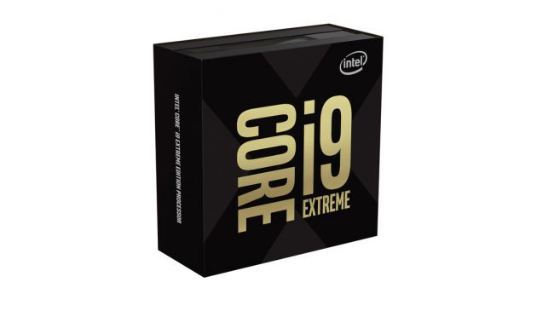**Cores:**18 | **Threads:**36 | **Base clock:**3.0GHz | **Boost clock:**4.4GHz | **L3 cache:**24.75MB | **TDP:**165W

Sits at the top of the HEDT stack

Insane multi-core performance

Whiplash-inducing cost

$2,549.99 at amazon

* 1. Provide an example of a medium speed CPU using the list of suppliers provided in the appendix. List the Model Number, Price, and Vendor Source. Also list its main features

**AMD Ryzen 7 3700X**

**Cores:**8 | **Threads:**16 | **Base clock:**3.6GHz | **Boost clock:**4.4GHz | **L3 cache:**32MB | **TDP:**65W

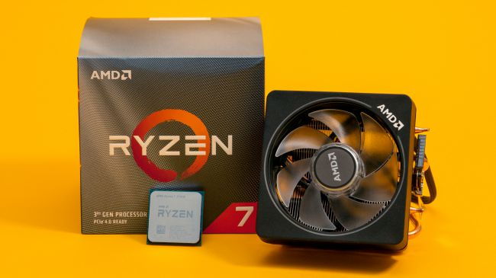Incredible price to performance

Affordable

Included cooler

Single-threaded performance still falls behind Intel

$429.99 at amazon

* 1. Provide an example of a basic speed CPU using the list of suppliers provided in the appendix. List the Model Number, Price, and Vendor Source. Also list its main features
  2. What would be the least expensive CPU Chip that meets your requirements? List the Model Number, Price, and Vendor Source.

Intel Pentium G4560

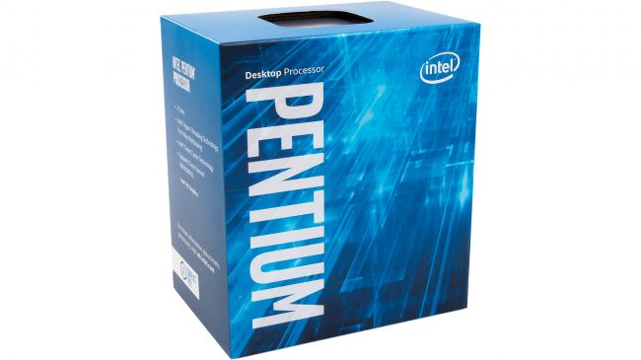Intel Core i3 power at a Pentium price tag

Cores: 2 | Threads: 4 | Base clock: 3.5GHz | L3 cache: 3MB | TDP: 54W

CDN$79.99

VIEW AT NEWEGG CANADA

1. RAM Memory
   1. What size of RAM Memory do you require? (Large / Medium / Basic)
      * Size of RAM memory required is medium
   2. Provide an example of a large size RAM using the list of suppliers provided in the appendix. List the Model Number, Price, and Vendor Source. Also list its main features
   3. Provide an example of a medium size RAM using the list of suppliers provided in the appendix. List the Model Number, Price, and Vendor Source. Also list its main features
   4. Provide an example of a basic size RAM using the list of suppliers provided in the appendix. List the Model Number, Price, and Vendor Source. Also list its main features
   5. What would be the least expensive RAM Memory that meets your requirements? List the Model Number, Price, and Vendor Source.
2. Graphics Card
   1. What graphics speed and resolution do you require? (High / Medium /Basic - On Motherboard)
   2. Provide an example of a high-end Graphics Card using the list of suppliers provided in the appendix. List the Model Number, Price, and Vendor Source. Also list its main features
   3. Provide an example of a medium-end Graphics Card using the list of suppliers provided in the appendix. List the Model Number, Price, and Vendor Source. Also list its main features
   4. What would be the least expensive Graphics Card that meets your requirements (or do you just need basic graphics provided by the motherboard)? List the Model Number, Price, and Vendor Source.
3. Sound Card
   1. Do you require special sound support? (High / Medium /Basic - On Motherboard)
      * Basic sound support
   2. Provide an example of a high-end Sound Card using the list of suppliers provided in the appendix. List the Model Number, Price, and Vendor Source. Also list its main features
   3. Provide an example of a medium-end Sound Card using the list of suppliers provided in the appendix. List the Model Number, Price, and Vendor Source. Also list its main features
   4. What would be the least expensive Sound Card that meets your requirements (or do you just need basic sound provided by the motherboard)? List the Model Number, Price, and Vendor Source.
4. Motherboard
   1. Do you require any special motherboard features (based on your answers to the above questions)?
   2. Provide an example of a high-end Motherboard using the list of suppliers provided in the appendix. List the Model Number, Price, and Vendor Source. Also list its main features
   3. Provide an example of a basic Motherboard using the list of suppliers provided in the appendix. List the Model Number, Price, and Vendor Source. Also list its main features
   4. What would be the least expensive Motherboard that meets your requirements? List the Model Number, Price, and Vendor Source.
5. HDD (Hard Disk Drive or Solid State Drive)
   1. Do you require any special Hard Disk Drive features (based on your answers to the above questions)?
   2. Provide an example of a high-end HDD using the list of suppliers provided in the appendix. List the Model Number, Price, and Vendor Source. Also list its main features
   3. Provide an example of a basic HDD using the list of suppliers provided in the appendix. List the Model Number, Price, and Vendor Source. Also list its main features
   4. What would be the least expensive Hard Disk Drive that meets your requirements? List the Model Number, Price, and Vendor Source.
6. Removable Media (DVD / USB / Flash)
   1. Do you require any special Removable Media features? Explain what extra features are required for your PC application topic.
   2. If so, List the Model Number, Price, and Vendor Source for any of these extra features.
7. Network Interface (Ethernet /Fiber / Wi-Fi / Bluetooth)
   1. Do you require any special Network Interface features? Explain what extra features are required for your PC application topic.
   2. If so, List the Model Number, Price, and Vendor Source for any of these extra features.
8. Monitor, Mouse, Keyboard
   1. Do you require any special Monitor, Mouse, Keyboard, etc. add-ons? Explain what extra features are required for your PC application topic.
   2. If so, List the Model Number, Price, and Vendor Source for any of these extra features.
9. Portability / Mobility
   1. Will you be using your PC in one place, do you need some portability, or do you need a high degree of mobility? Explain the need for portability your PC application topic.
   2. Do you require a Desktop / Laptop / Notebook or other PC format?
   3. How will this affect the cost of your dream machine.
10. Rank each personal computer component in order of priority (1-lowest, 10-highest) based on your research above. Each component must have its own priority number… no duplications.
    * CPU Processor Chip 6 1 2 3 4 5 6 7 8 9 10
    * RAM Memory 5 1 2 3 4 5 6 7 8 9 10
    * Graphics Card 1 1 2 3 4 5 6 7 8 9 10
    * Sound Card 9 1 2 3 4 5 6 7 8 9 10
    * Motherboard 7 1 2 3 4 5 6 7 8 9 10
    * HDD (Hard Disk Drive or Solid State Drive) 2 1 2 3 4 5 6 7 8 9 10
    * Removable Media (DVD / USB / Flash) 3 1 2 3 4 5 6 7 8 9 10
    * Network Interface (Ethernet /Fiber / Wi-Fi / Bluetooth) 4 1 2 3 4 5 6 7 8 9 10
    * Monitor, Mouse, Keyboard 10 1 2 3 4 5 6 7 8 9 10
    * Portability / Mobility 9 1 2 3 4 5 6 7 8 9 10

**Brochure**

Work individually to create a 4 page brochure according to the following guideline.

**Page 1 – Your Application Topic**

Describe your topic and the top PC components for your topic.

Include the following on this page:

* Describe your application topic and how a PC is used
* In general terms, describe what the best PC for this application would look like (e.g. speed vs portability)
* Describe in more detail the top three most important PC components and explain why they are important for your application

**Page 2 – Would-Be-Nice Features**

Describe your decisions about what PC components are less important but would be nice to upgrade if you had the money.

Include the following on this page:

* Describe the would-be-nice components (just below your top 3 priorities) and what your options for upgrading them would be.
* Describe the components / features at the bottom of your priority list and why you would not spend extra money on them.
* Provide some details about different vendors / suppliers and the options they offer.

**Page 3 – Your Budget Machine**

Your budget is $800. Select a pre-packaged PC or customize / build a PC from parts to fit under this budget.

Include the following on this page:

* Your PC specs, model, cost, vendor, etc.
* Priority components that you were able to include for this price.
* Priority components that you had to leave out because of budget limitations.

**Page 4 – Your Dream Machine**

Your budget is $2000. Select a pre-packaged PC or customize / build a PC from parts to fit under this budget.

Include the following on this page:

* Your PC specs, model, cost, vendor, etc.
* Priority components that you were able to include for this price.
* Priority components that you were able to spend extra on.
* Also comment on any priority components that you had to leave out or down-grade.

**Appendix A: PC Vendors, Parts, & Customization**

Suggested on-line computer sources:

* [www.newegg.ca](http://www.newegg.ca)
* [www.dell.com/en-ca](http://www.dell.com/en-ca)
* [www.tigerdirect.ca/](http://www.tigerdirect.ca/)
* [www.canadacomputers.com](http://www.canadacomputers.com)

**Appendix B: Application Topics**

|  |  |
| --- | --- |
| **Task** | **Student Name** |
| ***Game Computer*** |  |
| **Photo Editing & Organization** |  |
| ***Business Office Computer*** |  |
| ***Student Home Computer*** |  |
| ***Factory Floor Computer*** |  |
| ***Media Production and Streaming Computer*** |  |
| ***Web Surfing Computer*** |  |
| ***Game Computer*** |  |
| **Photo Editing & Organization** |  |
| ***Business Office Computer*** |  |
| ***Student Home Computer*** |  |
| ***Factory Floor Computer*** |  |
| ***Media Production and Streaming Computer*** |  |
| ***Web Surfing Computer*** |  |
| ***Game Computer*** |  |
| **Photo Editing & Organization** |  |
| ***Business Office Computer*** |  |
| ***Student Home Computer*** |  |
| ***Factory Floor Computer*** |  |
| ***Media Production and Streaming Computer*** |  |
| ***Web Surfing Computer*** |  |